**Question 2**

1. Run command in Workspace:
   1. Press left Button (on windows).
   2. Press Workspace 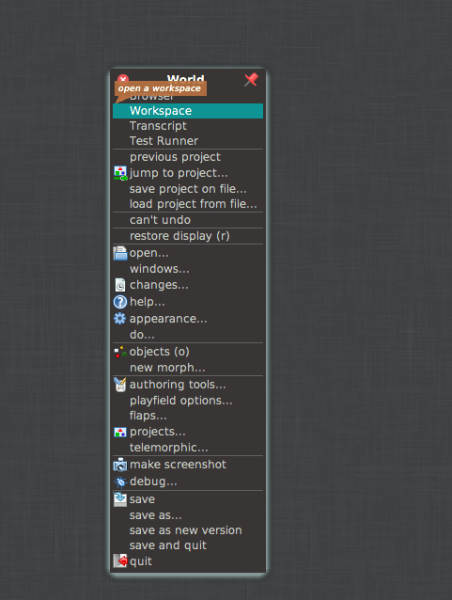
   3. Type the command
   4. Select the command
   5. Press left mouse button and press **do it (d)**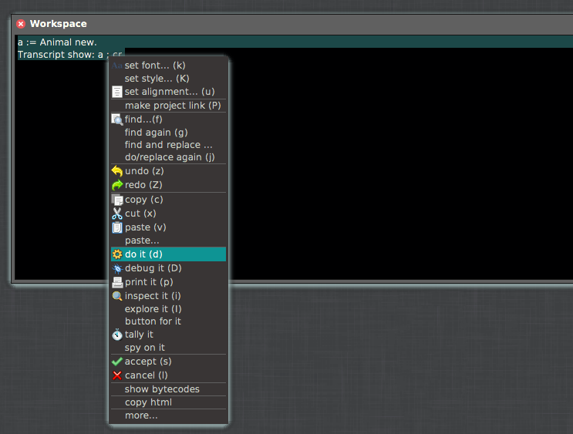
2. Find method printOn:
   1. Go to the right corner in Squeak and type there printOn:
   2. Implementation of printOn: window will pop up
   3. 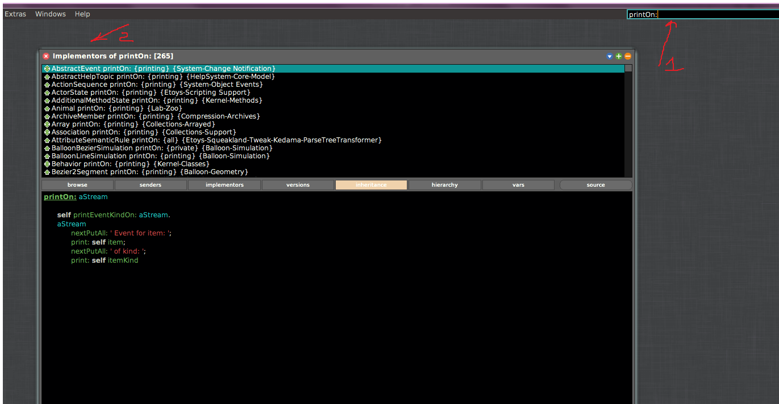
3. Find and jump to class Object:
   1. In the same search bar (right corner) type Object
   2. Browser window will pop up with Object class selected:
   3. 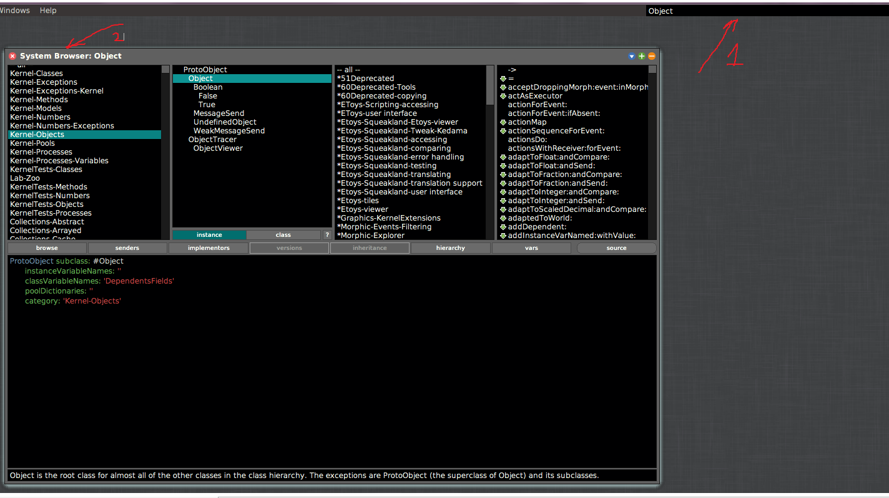
4. Find all methods what sends message printString
   1. Sdf

ה) Stop endless loop

* Press **Alt-.**  This will stop the loop and open “User Interrupt” window